**Prevent Hate Raids StreamerBot Extension [v1.0]**

**Created by Vengey**

**[** [**https://twitter.com/ItsVengey**](https://twitter.com/ItsVengey) **|** [**https://www.twitch.tv/itsvengey**](https://www.twitch.tv/itsvengey) **|** [**https://vengey.carrd.co/**](https://vengey.carrd.co/) **]**

The purpose of this plugin is to extend the existing functionality of Twitch’s own Shield Mode feature. With Shield Mode you can essentially lock your stream down to whatever you want, followers only, subscribers only etc..

However, it only does stuff on Twitch’s side of things, it doesn’t communicate with your OBS, nor StreamElements so while this is all well and good, you could still end up with bad usernames appearing on stream from hate raids and the like which is not what we want.

My goal is to make it so that as soon as you or a mod clicks that Shield Mode button on Twitch your whole backend is automated to put you and your viewers in a safe space once again with little to no trouble from the moderation team’s end!

If you have any questions, or run into any troubles with getting things set up, feel free to reach out to me (Vengey) and I can help point you in the right direction! Or if you encounter any bugs as well and I will make sure to keep this plugin up to date!

**How to Import into StreamerBot…**

**STEP 1: *Copy the LONG string from this file:***

[***https://drive.google.com/file/d/1JnKaPwIyx1T5NAIgX8HedzCP5X_qFLw5/view?usp=sharing***](https://drive.google.com/file/d/1JnKaPwIyx1T5NAIgX8HedzCP5X_qFLw5/view?usp=sharing)

**STEP 2**: ***Click Import in Streamerbot***

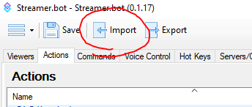

**STEP 3**: ***Paste the code into “Import String”, a list of actions will show up, make sure they’re all checked, then hit “Import”***

***In the next step we’ll actually configure the plugin, the “__READ ME__” action you are importing will also contain similar instructions on how to set things up as well.***

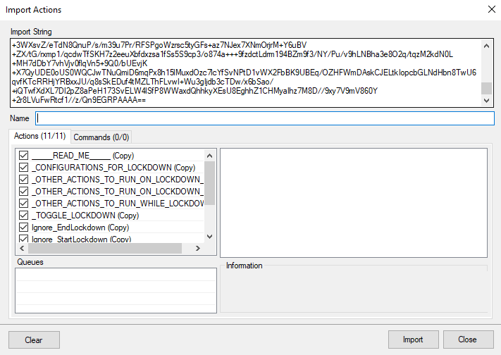

**STEP 4**: ***Setup the extension!***

1. ***Go to your Twitch channel and hit the little shield under chat, and turn shield mode on***  
   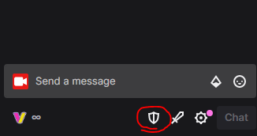
   1. Hit the little shield again to open shield mode settings
   2. Make sure all the settings are set up the way you want them to be
      1. Here’s an example of what the default Shield settings look like  
         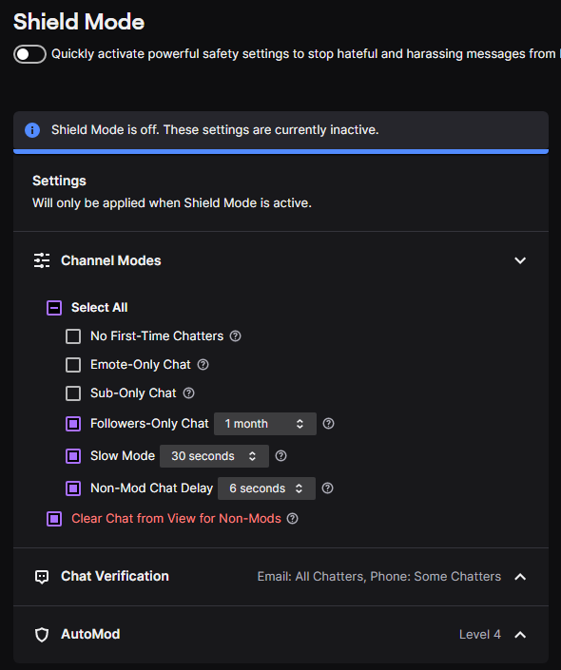  
           
         For most people these settings are pretty solid as they are, it sets auto mod to the maximum content filtering settings, chat verification to the maximum security settings, and makes it so that people that have been following for at least a month will not be impacted  
           
         But if these settings do not suit you, you can configure other things like “Sub Only mode” or “No First Time chatters”, though it’s important to note that you can have someone who has only ever been followed to you and has never talked before and could get bonked by this if they finally decide to talk months later!
   3. Click the slider button at the top to disable shield mode now that you're all setup
2. **Now go to StreamerBot…**
   1. **Go to Platforms > Twitch > Events > Moderation**
      1. ***Set "Shield Mode Begin" to "Ignore_StartLockdown"***
      2. ***Set "Shield Mode End" to "Ignore_EndLockdown"***  
         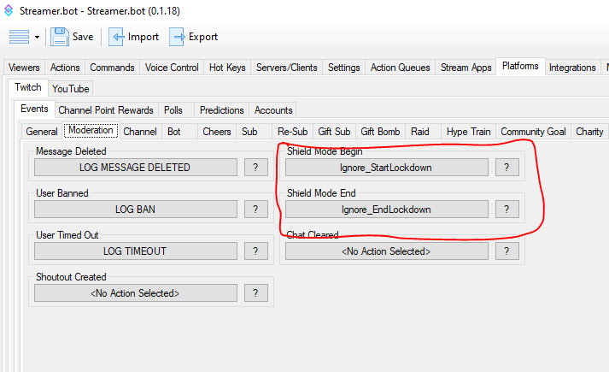
   2. **Go back to the “Actions” tab and open the Action named "_CONFIGURATIONS_FOR_LOCKDOWN"**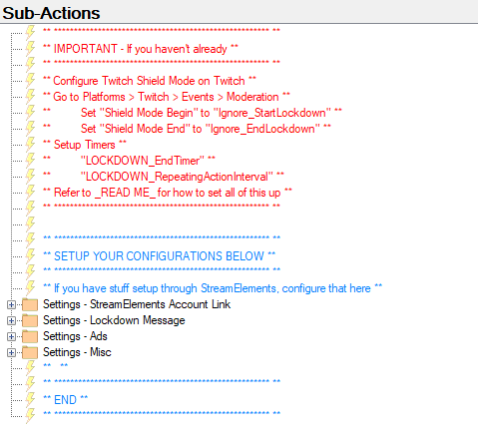
      1. **IF YOU USE STREAMELEMENTS**...Enter your JWT account token where it says “Set global…”  
         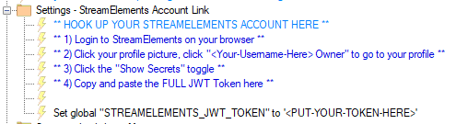

To get your token you can find it on your personal account profile page on the StreamElements website  
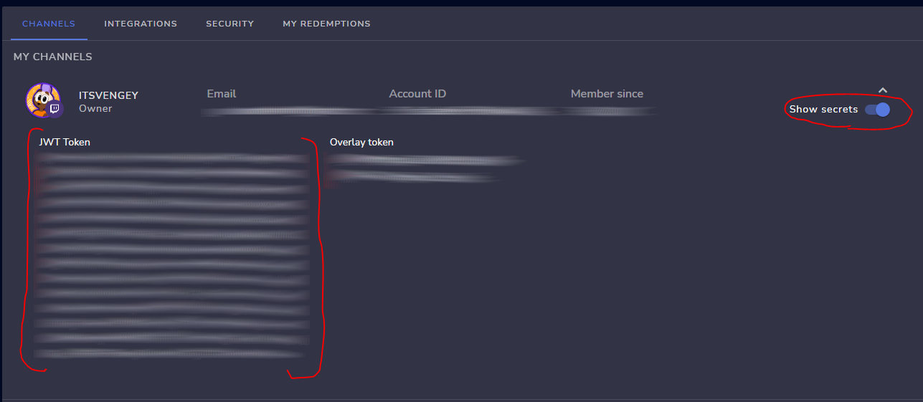  
  
What this will do is allow us to pause any alerts coming in from StreamElements AND clear out widget data so that if you have recent user overlays it will empty the user data out so it doesn’t display anything bad on stream labels for example.

* + 1. ***Other configurations!***
       1. We can also configure a message to display every couple minutes while on lockdown, display an AD to get the hate raiders’ ad revenue, among other things, feel free to configure those settings here as well! There are already some defaults all setup and ready to go for you they just need to be enabled!  
          
  1. **Setup the Required Timers**
     1. ***Go to Settings > Timed Actions***
     2. ***Add a new timer, and make it look exactly like this, name and all!***  
        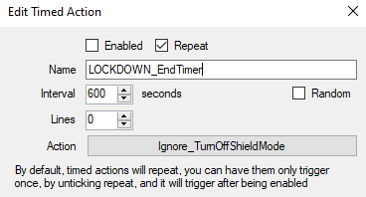
     3. ***Add another new timer, and make it look exactly like this, name and all!***  
        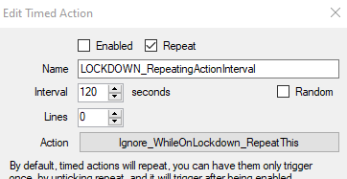

(sorry… Streamerbot wouldn’t let me export the timers I already had setup for you, so we have to configure them ourselves, BUT IT IS IMPORTANT you name the timers EXACTLY the way I provide them to you and set the actions to the exact actions listed…YOU MAY however adjust the timer interval and lines fields)

* 1. **The plugin doesn’t do everything I need it to?!?!**
     1. Not a worry I have you covered! Just add any additional sub-actions you need done to these three actions I generated! As they are described they will do whatever you tell it to do on; Start, End and During the Lockdown!  
        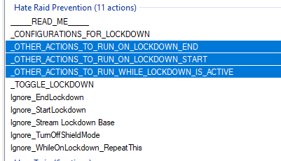

1. **Do you have a Streamdeck?**
   1. If you download this plugin you can call the _TOGGLE_LOCKDOWN action to put your stream into lockdown mode instead of hitting the Twitch shield mode button, pretty cool!  
      https://wiki.streamer.bot/en/Plugins/Stream-Deck